History Home Learning
Challenge 1:
With the help of a grown up in your house, phone someone in your family or a friend who is older than your parents and ask them these questions:
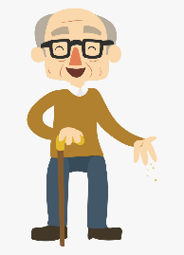
- What year were you born?

Answer:

- What is your earliest memory?
Answer:

- Who was the Prime Minister when you were born?

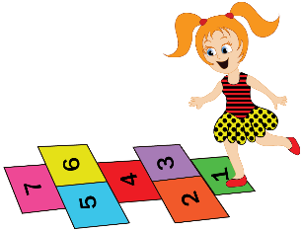
Answer:

- What was your favourite game to play as a child:

Answer:
- What was your favourite programme to watch on TV?

Answer:

- What was your favourite book to read or listen to when you were a child?
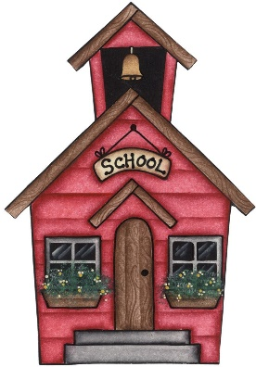

Answer:
- What was your school like?

Answer:

Now ask the same questions to your parents.

- What year were you born? Answer:

- What is your earliest memory?
Answer:

- Who was the Prime Minister when you were born?

Answer:

- What was your favourite game to play as a child:

Answer:
- What was your favourite programme to watch on TV?

Answer:

- What was your favourite book to read or listen to when you were a child?

Answer:
- What was your school like?
Answer:

Now answer the questions yourself!

- What year were you born? Answer:

- What is your earliest memory?
Answer:

- Who was the Prime Minister when you were born?

Answer:

- What is your favourite game to play:

Answer:
- What is your favourite programme to watch on TV?

Answer:

- What was is favourite book to read or listen to?

Answer:
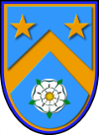

- What is your school like?

Answer:

Well done! You’ve been a great Historian. Ask a grown up if you can go onto Purple Mash and email the Woodhouse Teacher with your work. You should be able to upload it from your computer.

